Test Document

|  |  |  |  |  |  |
| --- | --- | --- | --- | --- | --- |
| Function Tested | Description | Input value | Expected output | WCF Test Output | Test Result |
| GetVenueNames(); | Lists all the venue names |  | 2 venues | Figure 1 | Passed |
| GetArtistNames(); | Lists the names of all the artists in the database |  | 7 artist names | Figure 2 | Passed |
| GetShowNames(); | Lists the names of all the shows |  | 5 show names | Figure 3 | Passed |
| GetVenueShows(); | Lists the show names, date and time for a particular venue | string venueName  Test input:  Comet | 2 shows | Figure 4 | Passed |
| GetArtistShows(); | Lists the show name, date, time and venue name for a particular artist | string artist  Test input:  Erik Blood | 1 show | Figure 5 | Passed |

Figure 1. - Test for GetVenueNames();

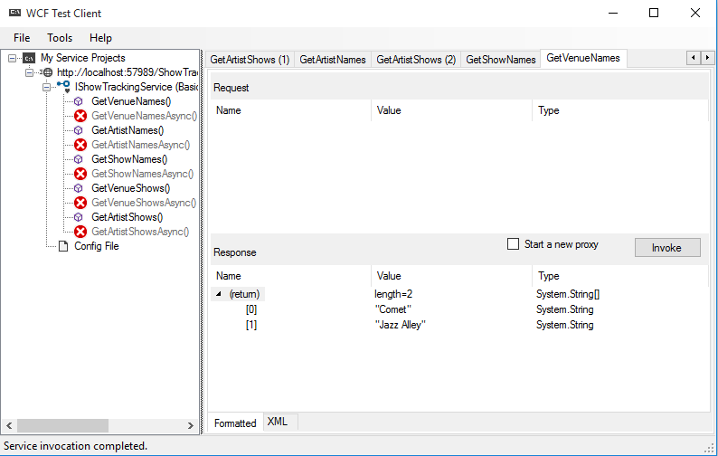

Figure 2. – Test for GetArtistNames();

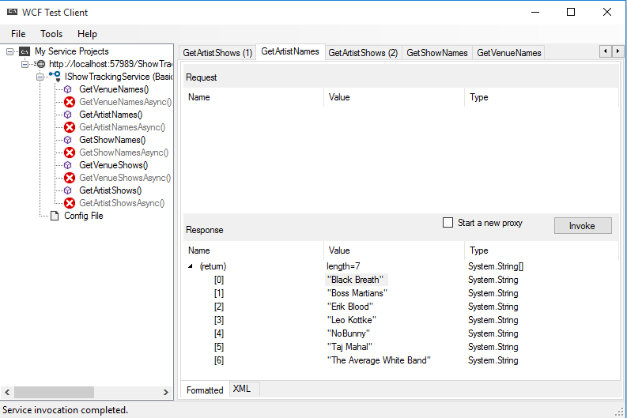

Figure 3. – Test for GetShowNames();

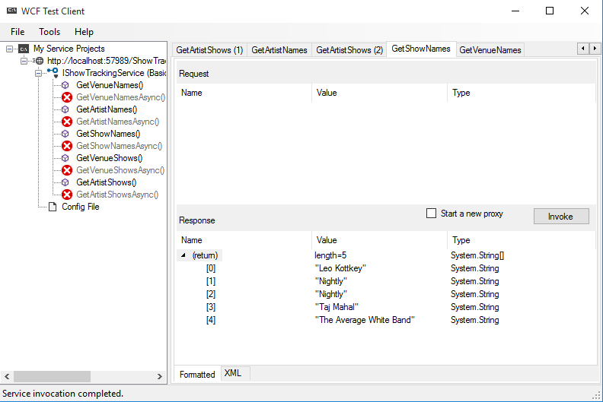

Figure 4. – Test for GetVenueShows();

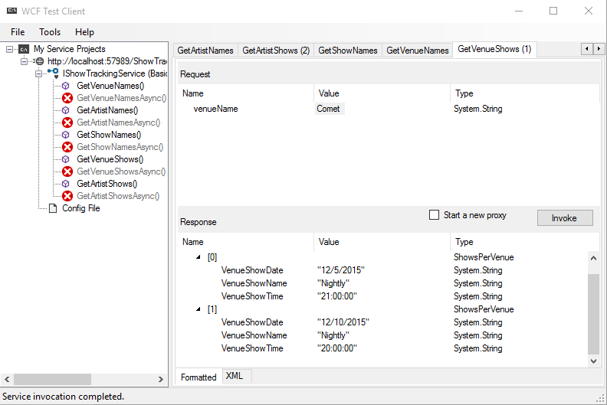

Figure 5. – Test for GetArtistShows();

